# Student-project---Disaster-Respons
In this student project we get a real dataset from Figure Eight where we would make a model that classifies disaster messages. We will make a maskinlearning model that classifies messages sent during disasters so helping organizations can put in correct help at the right time. These messages can be classified into one of 36 categories. In the end we made an APP where the classification of the messages can be classified in one or more of the categories. These so the people in the field can look at and analyse the incoming messages in real time, and got a graph over all the incoming messages, to get an overview of what's happening. See attachment for examples of some graphs.
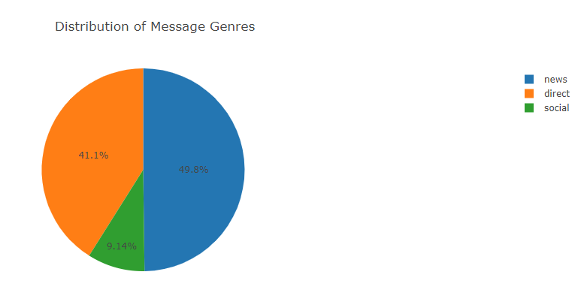

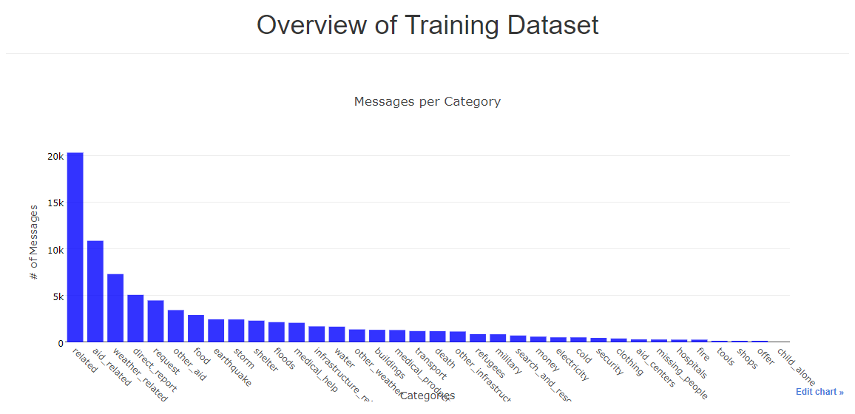

Make a web app: The app shows the classifications results
